**QA1 e-Business AWS Migration**

By: Evan Lai

Date: 01/17/2019

Version: 1.0

**Background Information:**

1. **All CCC E-Business Environments:**

DEV1: OAD1

DEV2: OAD1

QA: OAQ1

PRE1: OAR1

PS1: OAS1

PRD1: OAP1

PATCH: OAH1

1. **QA1 AWS Migration Source and Target:**

|  |  |
| --- | --- |
| Source | Target |
| oraoaq1@qa1ebdb1 | oraoaq1@shnpc1oradb1.aws-sh-npc.copyright.com |
| apploaq1@qa1oappall2 | apploaq1@shnpc1oappin2.aws-sh-npc.copyright.com |

1. **QA1 Target CONTEXT_NAME:**

OAQ1_shnpc1oradb1

**Part 1: Preparation (4 hours)**

**1.1 Create Database Backup controlfile**

**On qa1ebdb1:**

SQL> connect /as sysdba;

SQL> alter database backup controlfile to trace as '/home/oraoaq1/bin/migration/OAQ1-cpfile-bkp-20190107.trc';

**1.2 Prepare Oracle Software from the Source**

**1.2.1 Pre-Clone Steps on Source Database Host**

**On qa1ebdb1:**

Run pre-clone on Database Tier:

cd $ORACLE_HOME/appsutil/scripts/<CONTEXT_NAME>

(e.g.: cd /a01/oaq1db/12.1.0/appsutil/scripts/OAQ1_qa1ebdb1)

export TZ=-0500

[oraoaq1@qa1ebdb1 OAQ1_qa1ebdb1]$ perl adpreclone.pl dbTier

Copyright (c) 2011, 2014 Oracle Corporation

Redwood Shores, California, USA

Oracle E-Business Suite Rapid Clone

Version 12.2

adpreclone Version 120.31.12020000.18

Enter the APPS User Password:

Running:

perl /a01/oaq1db/12.1.0/appsutil/bin/adclone.pl java=/a01/oaq1db/12.1.0/appsutil/jre mode=stage stage=/a01/oaq1db/12.1.0/appsutil/clone component=dbTier method=CUSTOM dbctx=/a01/oaq1db/12.1.0/appsutil/OAQ1_qa1ebdb1.xml showProgress

Beginning database tier Stage - Mon Jan 7 15:17:29 2019

/a01/oaq1db/12.1.0/appsutil/jre/bin/java -Xmx600M -DCONTEXT_VALIDATED=false -Doracle.installer.oui_loc=/a01/oaq1db/12.1.0/oui -classpath /a01/oaq1db/12.1.0/lib/xmlparserv2.jar:/a01/oaq1db/12.1.0/jdbc/lib/ojdbc6.jar:/a01/oaq1db/12.1.0/appsutil/java:/a01/oaq1db/12.1.0/oui/jlib/OraInstaller.jar:/a01/oaq1db/12.1.0/oui/jlib/ewt3.jar:/a01/oaq1db/12.1.0/oui/jlib/share.jar:/a01/oaq1db/12.1.0/oui/jlib/srvm.jar:/a01/oaq1db/12.1.0/jlib/ojmisc.jar oracle.apps.ad.clone.StageDBTier -e /a01/oaq1db/12.1.0/appsutil/OAQ1_qa1ebdb1.xml -stage /a01/oaq1db/12.1.0/appsutil/clone -tmp /tmp -method CUSTOM -showProgress

APPS Password :

Log file located at /a01/oaq1db/12.1.0/appsutil/log/OAQ1_qa1ebdb1/StageDBTier_01071517.log

/ 50% completed

Completed Stage...

Mon Jan 7 15:17:49 2019

[oraoaq1@qa1ebdb1 OAQ1_qa1ebdb1]$

Backup the existing pfile and spfile.

create pfile from spfile;

or

SQL> create pfile='/home/oraoaq1/bin/migration/OAQ1-pfile-bkp-20190107.ora' from spfile;

**1.2.2 Pre-Clone Steps on Source Application Host**

**On qa1oappall2:**

Source the run file system:

. /u01/R12.2/apps/EBSapps.env run

Run pre-clone on Application Tier:

cd $ADMIN_SCRIPTS_HOME

[apploaq1@qa1oappall2 scripts]$ perl adpreclone.pl appsTier

Copyright (c) 2011, 2014 Oracle Corporation

Redwood Shores, California, USA

Oracle E-Business Suite Rapid Clone

Version 12.2

adpreclone Version 120.31.12020000.18

Enter the APPS User Password:

Enter the Weblogic AdminServer password :

Checking the status of the Oracle WebLogic Administration Server....

Running perl /u01/R12.2/apps/fs1/EBSapps/appl/ad/12.0.0/patch/115/bin/adProvisionEBS.pl ebs-get-serverstatus -contextfile=/u01/R12.2/apps/fs1/inst/apps/OAQ1_qa1oappall2/appl/admin/OAQ1_qa1oappall2.xml -servername=AdminServer -promptmsg=hide

The Oracle WebLogic Administration Server is up.

Running:

perl /u01/R12.2/apps/fs1/EBSapps/appl/ad/12.0.0/bin/adclone.pl java=/u01/R12.2/apps/fs1/EBSapps/comn/util/jdk64 mode=stage stage=/u01/R12.2/apps/fs1/EBSapps/comn/clone component=appsTier method= appctx=/u01/R12.2/apps/fs1/inst/apps/OAQ1_qa1oappall2/appl/admin/OAQ1_qa1oappall2.xml showProgress

Setting the wls environment

Beginning application tier Stage - Mon Jan 7 10:31:33 2019

/u01/R12.2/apps/fs1/EBSapps/comn/util/jdk64/bin/java -Xmx600M -DCONTEXT_VALIDATED=false -Doracle.installer.oui_loc=/oui -classpath /u01/R12.2/apps/fs1/FMW_Home/webtier/lib/xmlparserv2.jar:/u01/R12.2/apps/fs1/FMW_Home/webtier/jdbc/lib/ojdbc6.jar:/u01/R12.2/apps/fs1/EBSapps/comn/java/classes:/u01/R12.2/apps/fs1/FMW_Home/webtier/oui/jlib/OraInstaller.jar:/u01/R12.2/apps/fs1/FMW_Home/webtier/oui/jlib/ewt3.jar:/u01/R12.2/apps/fs1/FMW_Home/webtier/oui/jlib/share.jar:/u01/R12.2/apps/fs1/FMW_Home/webtier/../Oracle_EBS-app1/oui/jlib/srvm.jar:/u01/R12.2/apps/fs1/FMW_Home/webtier/jlib/ojmisc.jar:/u01/R12.2/apps/fs1/FMW_Home/wlserver_10.3/server/lib/weblogic.jar:/u01/R12.2/apps/fs1/FMW_Home/oracle_common/jlib/obfuscatepassword.jar oracle.apps.ad.clone.StageAppsTier -e /u01/R12.2/apps/fs1/inst/apps/OAQ1_qa1oappall2/appl/admin/OAQ1_qa1oappall2.xml -stage /u01/R12.2/apps/fs1/EBSapps/comn/clone -tmp /tmp -method CUSTOM -showProgress -nopromptmsg

Log file located at /u01/R12.2/apps/fs1/inst/apps/OAQ1_qa1oappall2/admin/log/clone/StageAppsTier_01071031.log

/ 20% completed

Completed Stage...

Mon Jan 7 10:39:15 2019

[apploaq1@qa1oappall2 scripts]$

**Starting Down Time….**

**Part 2: Copy Software of DB and Apps Tiers and DB Backup to AWS (Total: 11 hours)**

* 1. **Enable Decoupled Mode (30 minutes)**

**On qa1ebdb1:**

1. [oraoaq1@qa1ebdb1 bin]$ source /a01/oaq1db/12.1.0/OAQ1_qa1ebdb1.env
2. Modify the tns ifile to disable the custom database links:
   1. vi /a01/oaq1db/12.1.0/network/admin/OAQ1_qa1ebdb1/OAQ1_qa1ebdb1_ifile.ora

**On qa1cccdb1:**

1. vi $ORACLE_HOME/network/admin/tnsnames.ora

Disable entry for OAQ1

**On shnpc1dw1:**

1. vi $ORACLE_HOME/network/admin/tnsnames.ora

Disable entry for OAQ1

* 1. **Bring down the application and database services. (30 minutes)**

**On qa1ebdb1:**

Cd /home/oraoaq1/bin

[oraoaq1@qa1ebdb1 bin]$ ./shut12gAgent

[oraoaq1@qa1ebdb1 bin]$ ./shutOAQ1.sh

Rename all startup scripts:

[oraoaq1@qa1ebdb1 bin]$ mv start12gAgent start12gAgent-DO-NOT-USE

[oraoaq1@qa1ebdb1 bin]$ mv startOAQ1db.sh startOAQ1db.sh-DO-NOT-USE

[oraoaq1@qa1ebdb1 bin]$ mv startOAQ1.sh startOAQ1.sh-DO-NOT-USE

* 1. **Create tar file for the database tier and copy it to AWS (45 minutes)**

**On qa1ebdb1:**

Create tar file for Oracle Home: (30 minutes)

[oraoaq1@qa1ebdb1 oaq1db]$ cd /a01/oaq1db

[oraoaq1@qa1ebdb1 oaq1db]$ tar czfp 12.1.0_OAQ1-20190107.tgz ./12.1.0

Copy the tar file to the target database host : (15 minutes)



**2.4 Create tar file for the apps tier and copy it to AWS (1 hour 30 minutes)**

**On qa1oappall2:**

Create tar file for Apps tier: (1 hour)

Source the run file system:

. /u01/R12.2/apps/EBSapps.env run

[apploaq1@qa1oappall2 fs1]$ cd $RUN_BASE

tar czpf EBSapps_OAQ1-20190107.tgz ./EBSapps

Cope the tar file to target apps tier host: (22 GB, about 10 minutes)

[apploaq1@qa1oappall2 fs1]$ scp EBSapps_OAQ1-20190107.tgz [apploaq1@shnpc1oappin2:/u01/R12.2/apps/fs1](mailto:apploaq1@shnpc1oappin2:/u01/R12.2/apps/fs1)

**2.5 Copy data files to AWS (7 hours)**

**On qa1ebdb1:**

Copy the datafiles from the source to target host for /a02, /a03, a04: (Total about 7 hours)

[oraoaq1@qa1ebdb1 oaq1data]$ scp * [oraoaq1@shnpc1oradb1.aws-sh-npc.copyright.com:/a12/oaq1data](mailto:oraoaq1@shnpc1oradb1.aws-sh-npc.copyright.com:/a12/oaq1data)

**Part 3: Clone the Database Tier on AWS (Total: 4 hours)**

**3.1 Clone the Database Tier Software (1 hour)**

**On shnpc1oradb1:**

**Confirm the Oracle inventory pointing to location below:**

inventory_loc=/a11/oaq1db/oraInventory

mkdir -p /a11/oaq1db/oraInventory

**Create data top directory:**

oraoaq1@shnpc1oradb1 a12]$ mkdir -p /a12/oaq1data

**Untar the tar file: (30 minutes)**

[oraoaq1@shnpc1oradb1 oaq1db]$ cd /a11/oaq1db

[oraoaq1@shnpc1oradb1 oaq1db]$ tar xpfz 12.1.0_OAQ1-20190107.tgz

**** **For share environment running on /a11 only** *****

cd /a11/oaq1db/12.1.0/appsutil/clone/jre

rm bin

ln -s /a11/oaq1db/12.1.0/jdk/bin

cd /a11/oaq1db/12.1.0/appsutil/jre

rm bin

ln -s /a11/oaq1db/12.1.0/jdk/bin

************************************************

**Clone the Home database home: (15 minutes)**

[oraoaq1@shnpc1oradb1 jre]$ cd /a11/oaq1db/12.1.0/appsutil/clone/bin

[oraoaq1@shnpc1oradb1 bin]$ perl adcfgclone.pl dbTechStack

Copyright (c) 2002, 2015 Oracle Corporation

Redwood Shores, California, USA

Oracle E-Business Suite Rapid Clone

Version 12.2

adcfgclone Version 120.63.12020000.56

Enter the APPS password :

Running: Context clone...

Log file located at /a11/oaq1db/12.1.0/appsutil/clone/bin/CloneContext_0108115025.log

Provide the values required for creation of the new Database Context file.

Target System Hostname (virtual or normal) [shnpc1oradb1] :

Target Instance is RAC (y/n) [n] :

Target System Database SID : OAQ1

Target System Base Directory : /a11/oaq1db

Target System utl_file_dir Directory List : /usr/tmp

Number of DATA_TOP's on the Target System [3] : 1

Target System DATA_TOP Directory 1 : /a12/oaq1data

Target System RDBMS ORACLE_HOME Directory [/a11/oaq1db/12.1.0] :

Do you want to preserve the Display [qa1ebdb1:6.0] (y/n) : n

Target System Display [shnpc1oradb1:0.0] :

Do you want the target system to have the same port values as the source system (y/n) [y] ? : n

Target System Port Pool [0-99] : 6

Checking the port pool 6

done: Port Pool 6 is free

Report file located at /a11/oaq1db/12.1.0/appsutil/temp/portpool.lst

The new database context file has been created :

/a11/oaq1db/12.1.0/appsutil/OAQ1_shnpc1oradb1.xml

Check Clone Context logfile /a11/oaq1db/12.1.0/appsutil/clone/bin/CloneContext_0108115025.log for details.

Running Rapid Clone with command:

Running:

perl /a11/oaq1db/12.1.0/appsutil/clone/bin/adclone.pl java=/a11/oaq1db/12.1.0/appsutil/clone/bin/../jre mode=apply stage=/a11/oaq1db/12.1.0/appsutil/clone component=dbTechStack method=CUSTOM dbctxtg=/a11/oaq1db/12.1.0/appsutil/OAQ1_shnpc1oradb1.xml showProgress contextValidated=true

Beginning rdbms home Apply - Tue Jan 8 11:51:48 2019

/a11/oaq1db/12.1.0/appsutil/clone/bin/../jre/bin/java -Xmx600M -DCONTEXT_VALIDATED=true -Doracle.installer.oui_loc=/a11/oaq1db/12.1.0/oui -classpath /a11/oaq1db/12.1.0/appsutil/clone/jlib/xmlparserv2.jar:/a11/oaq1db/12.1.0/appsutil/clone/jlib/ojdbc6.jar:/a11/oaq1db/12.1.0/appsutil/clone/jlib/java:/a11/oaq1db/12.1.0/appsutil/clone/jlib/oui/OraInstaller.jar:/a11/oaq1db/12.1.0/appsutil/clone/jlib/oui/ewt3.jar:/a11/oaq1db/12.1.0/appsutil/clone/jlib/oui/share.jar:/a11/oaq1db/12.1.0/appsutil/clone/jlib/oui/srvm.jar:/a11/oaq1db/12.1.0/appsutil/clone/jlib/ojmisc.jar oracle.apps.ad.clone.ApplyDBTechStack -e /a11/oaq1db/12.1.0/appsutil/OAQ1_shnpc1oradb1.xml -stage /a11/oaq1db/12.1.0/appsutil/clone -showProgress

APPS Password : Log file located at /a11/oaq1db/12.1.0/appsutil/log/OAQ1_shnpc1oradb1/ApplyDBTechStack_01081151.log

/ 0% completed

Completed Apply...

Tue Jan 8 11:53:29 2019

Starting database listener for OAQ1:

Running:

/a11/oaq1db/12.1.0/appsutil/scripts/OAQ1_shnpc1oradb1/addlnctl.sh start OAQ1

Logfile: /a11/oaq1db/12.1.0/appsutil/log/OAQ1_shnpc1oradb1/addlnctl.txt

You are running addlnctl.sh version 120.4

Starting listener process OAQ1 ...

LSNRCTL for Linux: Version 12.1.0.2.0 - Production on 08-JAN-2019 11:53:29

Copyright (c) 1991, 2014, Oracle. All rights reserved.

Starting /a11/oaq1db/12.1.0/bin/tnslsnr: please wait...

TNSLSNR for Linux: Version 12.1.0.2.0 - Production

System parameter file is /a11/oaq1db/12.1.0/network/admin/OAQ1_shnpc1oradb1/listener.ora

Log messages written to /a11/oaq1db/12.1.0/admin/OAQ1_shnpc1oradb1/diag/tnslsnr/shnpc1oradb1/oaq1/alert/log.xml

Listening on: (DESCRIPTION=(ADDRESS=(PROTOCOL=tcp)(HOST=shnpc1oradb1.aws-sh-npc.copyright.com)(PORT=1527)))

Connecting to (DESCRIPTION=(ADDRESS=(PROTOCOL=TCP)(HOST=shnpc1oradb1.aws-sh-npc.copyright.com)(PORT=1527)))

STATUS of the LISTENER

------------------------

Alias OAQ1

Version TNSLSNR for Linux: Version 12.1.0.2.0 - Production

Start Date 08-JAN-2019 11:53:29

Uptime 0 days 0 hr. 0 min. 0 sec

Trace Level off

Security ON: Local OS Authentication

SNMP OFF

Listener Parameter File /a11/oaq1db/12.1.0/network/admin/OAQ1_shnpc1oradb1/listener.ora

Listener Log File /a11/oaq1db/12.1.0/admin/OAQ1_shnpc1oradb1/diag/tnslsnr/shnpc1oradb1/oaq1/alert/log.xml

Listening Endpoints Summary...

(DESCRIPTION=(ADDRESS=(PROTOCOL=tcp)(HOST=shnpc1oradb1.aws-sh-npc.copyright.com)(PORT=1527)))

Services Summary...

Service "OAQ1" has 1 instance(s).

Instance "OAQ1", status UNKNOWN, has 1 handler(s) for this service...

The command completed successfully

**Confirm the new database context file and environment file have been created:**

/a11/oaq1db/12.1.0/appsutil/OAQ1_shnpc1oradb1.xml

/a11/oaq1db/12.1.0/OAQ1_shnpc1oradb1.env

**3.2 Configure Database and Listener (1 hour)**

**Copy the bin directory from the source to target host:**

**On shnpc1oradb1:**

cd “/

mkdir bin

mkdir log

**On qa1ebdb1:**

[oraoaq1@qa1ebdb1 bin]$ cd /home/oraoaq1/bin

[oraoaq1@qa1ebdb1 bin]$ scp -rp * oraoaq1@shnpc1oradb1.aws-sh-npc.copyright.com:/home/oraoaq1/bin

**On shnpc1oradb1:**

**Source the new environment file:**

. /a11/oaq1db/12.1.0/OAQ1_shnpc1oradb1.env

Cd $ORACLE_HOME/network/admin

[oraoaq1@shnpc1oradb1 admin]$ ln -s /a11/oaq1db/12.1.0/network/admin/OAQ1_shnpc1oradb1/listener.ora

ln: failed to create symbolic link \u2018./listener.ora\u2019: File exists

[oraoaq1@shnpc1oradb1 admin]$ rm listener.ora

[oraoaq1@shnpc1oradb1 admin]$ ln -s /a11/oaq1db/12.1.0/network/admin/OAQ1_shnpc1oradb1/listener.ora

[oraoaq1@shnpc1oradb1 admin]$ rm tnsnames.ora

[oraoaq1@shnpc1oradb1 admin]$ ln -s /a11/oaq1db/12.1.0/network/admin/OAQ1_shnpc1oradb1/tnsnames.ora

[oraoaq1@shnpc1oradb1 admin]$ rm sqlnet.ora

[oraoaq1@shnpc1oradb1 admin]$ ln -s /a11/oaq1db/12.1.0/network/admin/OAQ1_shnpc1oradb1/sqlnet.ora

**Copy the sqlnet.ora manually from the source. Add ifile for listener.ora, tnsnames.ora, and sqlnet.ora accordingly. Adjust setting accordingly.**

**Stop and Start the listener:**

$ORACLE_HOME/bin/lsnrctl stop OAQ1

$ORACLE_HOME/bin/lsnrctl start OAQ1

**Bring up the database:**

mkdir -p /afb11/oraadm/flash_recovery_area

Cd bin\migration

**Modify the pfile accordingly. Bring up the database in nomount and test.**

[oraoaq1@shnpc1oradb1 migration]$ sqlplus /nolog

SQL*Plus: Release 12.1.0.2.0 Production on Thu Jan 10 09:54:24 2019

Copyright (c) 1982, 2014, Oracle. All rights reserved.

SQL> connect /as sysdba;

Connected to an idle instance.

SQL> create spfile from pfile='/home/oraoaq1/bin/migration/OAQ1-pfile-bkp-20190107.ora';

File created.

SQL> startup nomount

ORA-32004: obsolete or deprecated parameter(s) specified for RDBMS instance

ORACLE instance started.

Total System Global Area 3.4360E+10 bytes

Fixed Size 3731384 bytes

Variable Size 1073741896 bytes

Database Buffers 3.3219E+10 bytes

Redo Buffers 63377408 bytes

SQL> shutdown abort;

ORACLE instance shut down.

SQL>

**Modify the control file backup accordingly. Bring up the database.**

[oraoaq1@shnpc1oradb1 migration]$ sqlplus /nolog

SQL*Plus: Release 12.1.0.2.0 Production on Thu Jan 10 10:02:26 2019

Copyright (c) 1982, 2014, Oracle. All rights reserved.

SQL> connect /as sysdba;

Connected.

SQL> @OAQ1-cpfile-bkp-20190107.sql

ORA-32004: obsolete or deprecated parameter(s) specified for RDBMS instance

ORACLE instance started.

Total System Global Area 3.4360E+10 bytes

Fixed Size 3731384 bytes

Variable Size 1073741896 bytes

Database Buffers 3.3219E+10 bytes

Redo Buffers 63377408 bytes

Control file created.

PL/SQL procedure successfully completed.

PL/SQL procedure successfully completed.

PL/SQL procedure successfully completed.

**Perform a few checks:**

Sqlplus /nolog

Connect /as sysdba;

Shutdown immediate;

Startup

Alter system switch logfile;

…..

Exit

**3.3 Configure RMAN (15 minutes)**

[oraoaq1@shnpc1oradb1 OAQ1PD1]$ mkdir -p /afb11/oraadm/flash_recovery_area/OAQ1PD1/autobackup

[oraoaq1@shnpc1oradb1 OAQ1PD1]$ rman target /

Recovery Manager: Release 12.1.0.2.0 - Production on Thu Jan 10 10:29:15 2019

Copyright (c) 1982, 2014, Oracle and/or its affiliates. All rights reserved.

connected to target database: OAQ1 (DBID=601509470)

RMAN> show all;

using target database control file instead of recovery catalog

RMAN configuration parameters for database with db_unique_name OAQ1PD1 are:

CONFIGURE RETENTION POLICY TO REDUNDANCY 2;

CONFIGURE BACKUP OPTIMIZATION OFF; # default

CONFIGURE DEFAULT DEVICE TYPE TO DISK; # default

CONFIGURE CONTROLFILE AUTOBACKUP ON;

CONFIGURE CONTROLFILE AUTOBACKUP FORMAT FOR DEVICE TYPE DISK TO '/afb02/oraadm/flash_recovery_area/OAQ1PD1/autobackup/%F';

CONFIGURE DEVICE TYPE DISK PARALLELISM 2 BACKUP TYPE TO COMPRESSED BACKUPSET;

CONFIGURE DATAFILE BACKUP COPIES FOR DEVICE TYPE DISK TO 1; # default

CONFIGURE ARCHIVELOG BACKUP COPIES FOR DEVICE TYPE DISK TO 1; # default

CONFIGURE CHANNEL DEVICE TYPE DISK MAXPIECESIZE 5120 M;

CONFIGURE MAXSETSIZE TO UNLIMITED; # default

CONFIGURE ENCRYPTION FOR DATABASE OFF; # default

CONFIGURE ENCRYPTION ALGORITHM 'AES128'; # default

CONFIGURE COMPRESSION ALGORITHM 'BASIC' AS OF RELEASE 'DEFAULT' OPTIMIZE FOR LOAD TRUE ; # default

CONFIGURE RMAN OUTPUT TO KEEP FOR 7 DAYS; # default

CONFIGURE ARCHIVELOG DELETION POLICY TO NONE; # default

CONFIGURE SNAPSHOT CONTROLFILE NAME TO '/a11/oaq1db/12.1.0/dbs/snapcf_OAQ1.f'; # default

RMAN> CONFIGURE CONTROLFILE AUTOBACKUP FORMAT FOR DEVICE TYPE DISK TO '/afb11/oraadm/flash_recovery_area/OAQ1PD1/autobackup/%F';

old RMAN configuration parameters:

CONFIGURE CONTROLFILE AUTOBACKUP FORMAT FOR DEVICE TYPE DISK TO '/afb02/oraadm/flash_recovery_area/OAQ1PD1/autobackup/%F';

new RMAN configuration parameters:

CONFIGURE CONTROLFILE AUTOBACKUP FORMAT FOR DEVICE TYPE DISK TO '/afb11/oraadm/flash_recovery_area/OAQ1PD1/autobackup/%F';

new RMAN configuration parameters are successfully stored

RMAN> exit

**3.4 Update and Test DBA Scripts (15 minutes)**

**Add the following entry to /etc/oratab file:**

OAQ1:/a11/oaq1db/12.1.0:N

**Update and test the shutdown and startup scripts**

**3.5 Database Post Clone Steps (45 minutes)**

**DE-REGISTER THE CURRENT CONFIGURATION**

SQL> connect apps/xxxxx

Connected.

SQL> exec fnd_conc_clone.setup_clean;

PL/SQL procedure successfully completed.

SQL> commit;

Commit complete.

SQL> connect /as sysdba;

Connected.

SQL> @$ORACLE_HOME/rdbms/admin/utlrp.sql

**EXECUTE AUTOCONFIG ON TARGET DATABASE NODE**

[oraoaq1@shnpc1oradb1 OAQ1_shnpc1oradb1]$ cd /a11/oaq1db/12.1.0/appsutil/scripts/OAQ1_shnpc1oradb1

[oraoaq1@shnpc1oradb1 OAQ1_shnpc1oradb1]$ ./adautocfg.sh

Enter the APPS user password:

The log file for this session is located at: /a11/oaq1db/12.1.0/appsutil/log/OAQ1_shnpc1oradb1/01101051/adconfig.log

AutoConfig is configuring the Database environment...

AutoConfig will consider the custom templates if present.

Using ORACLE_HOME location : /a11/oaq1db/12.1.0

Classpath : :/a11/oaq1db/12.1.0/jdbc/lib/ojdbc6.jar:/a11/oaq1db/12.1.0/appsutil/java/xmlparserv2.jar:/a11/oaq1db/12.1.0/appsutil/java:/a11/oaq1db/12.1.0/jlib/netcfg.jar:/a11/oaq1db/12.1.0/jlib/ldapjclnt12.jar

Using Context file : /a11/oaq1db/12.1.0/appsutil/OAQ1_shnpc1oradb1.xml

Context Value Management will now update the Context file

Updating Context file...COMPLETED

Attempting upload of Context file and templates to database...COMPLETED

Updating rdbms version in Context file to db121

Updating rdbms type in Context file to 64 bits

Configuring templates from ORACLE_HOME ...

AutoConfig completed successfully.

[oraoaq1@shnpc1oradb1 OAQ1_shnpc1oradb1]$

**Part 4: Clone the Application Tier on AWS (Total 9 hours)**

**4.1 Un-Tar apps tie file (30 minutes)**

**On qa1oappall2:**

**Un-tar the apps tier file:**

cd /u01/R12.2/apps/fs1

tar xpfz EBSapps_OAQ1-20190107.tgz

**4.2 Perform Pre-Clone Checks: (15 minutes)**

**Check hosts and network files:**

[apploaq1@shnpc1oappin2 fs1]$ more /etc/hosts

127.0.0.1 localhost.localdomain localhost

::1 localhost localhost.localdomain localhost6 localhost6.localdomain6

# 10.53.32.103 shnpc1oappin1.aws-sh-npc.copyright.com shnpc1oappin1.copyright.com shnpc1oappin1

10.53.32.54 shnpc1oappin2.aws-sh-npc.copyright.com shnpc1oappin2

23.207.172.96 yum.oracle.com

[apploaq1@shnpc1oappin2 fs1]$ more /etc/sysconfig/network

NETWORKING=yes

NOZEROCONF=yes

HOSTNAME=shnpc1oappin2.aws-sh-npc.copyright.com

[apploaq1@shnpc1oappin2 fs1]$

**Check Oracle Inventory:**

[apploaq1@shnpc1oappin2 fs1]$ more /etc/oraInst.loc

inventory_loc=/u01/oraInventory

inst_group=oinstall

[apploaq1@shnpc1oappin2 fs1]$ mkdir -p /u01/oraInventory

**Check database connection:**

[apploaq1@shnpc1oappin2 fs1]$ telnet shnpc1oradb1.aws-sh-npc.copyright.com 1527

Trying 10.53.32.46...

Connected to shnpc1oradb1.aws-sh-npc.copyright.com.

Escape character is '^]'.

^C

Connection closed by foreign host.

[apploaq1@shnpc1oappin2 fs1]$

**4.3 Perform Clone Steps: (6 hours)**

**Navigate to $COMMON_TOP/clone/bin, start the apps tier clone process:**

cd /u01/R12.2/apps/fs1/EBSapps/comn/clone/bin

[apploaq1@shnpc1oappin2 bin]$ perl adcfgclone.pl appsTier dualfs

Copyright (c) 2002, 2015 Oracle Corporation

Redwood Shores, California, USA

Oracle E-Business Suite Rapid Clone

Version 12.2

adcfgclone Version 120.63.12020000.56

Enter the APPS password :

Enter the Weblogic AdminServer password :

Do you want to add a node (yes/no) [no] :

Running: Context clone...

Log file located at /u01/R12.2/apps/fs1/EBSapps/comn/clone/bin/CloneContext_0114095740.log

Provide the values required for creation of the new APPL_TOP Context file.

Target System Hostname (virtual or normal) [shnpc1oappin2] :

Target System Database SID : OAQ1

Target System Database Server Node [shnpc1oappin2] : shnpc1oradb1

Target System Database Domain Name [aws-sh-npc.copyright.com] : aws-sh-npc.copyright.com

Target System Base Directory : /u01/R12.2/apps

Target System Base Directory set to /u01/R12.2/apps

Target System Current File System Base set to /u01/R12.2/apps/fs1

Target System Other File System Base set to /u01/R12.2/apps/fs2

Target System Fusion Middleware Home set to /u01/R12.2/apps/fs1/FMW_Home

Target System Other File System Fusion Middleware Home set to /u01/R12.2/apps/fs2/FMW_Home

Target System Web Oracle Home set to /u01/R12.2/apps/fs1/FMW_Home/webtier

Target System Other File System Web Oracle Home set to /u01/R12.2/apps/fs2/FMW_Home/webtier

Target System Appl TOP set to /u01/R12.2/apps/fs1/EBSapps/appl

Target System Other File System Appl TOP set to /u01/R12.2/apps/fs2/EBSapps/appl

Target System COMMON TOP set to /u01/R12.2/apps/fs1/EBSapps/comn

Target System Other File System COMMON TOP set to /u01/R12.2/apps/fs2/EBSapps/comn

Target System Instance Home Directory [/u01/R12.2/apps] :

Target System Current File System Instance Top set to /u01/R12.2/apps/fs1/inst/apps/OAQ1_shnpc1oappin2

Do you want to preserve the Display [qa1oappall2:6.0] (y/n) : n

Target System Display [shnpc1oappin2:0.0] : shnpc1oappin2:1:0

Target System Root Service [enabled] :

Target System Web Entry Point Services [enabled] :

Target System Web Application Services [enabled] :

Target System Batch Processing Services [enabled] :

Target System Other Services [enabled] :

Do you want the target system to have the same port values as the source system (y/n) [y] ? : n

Target System Port Pool [0-99] : 6

Checking the port pool 6

done: Port Pool 6 is free

Report file located at /u01/R12.2/apps/fs1/inst/apps/OAQ1_shnpc1oappin2/admin/out/portpool.lst

UTL_FILE_DIR on database tier consists of the following directories.

1. /usr/tmp

2. /usr/tmp

3. /a11/oaq1db/12.1.0/appsutil/outbound/OAQ1_shnpc1oradb1

4. /usr/tmp

Choose a value which will be set as APPLPTMP value on the target node [1] :

The new APPL_TOP context file has been created :

/u01/R12.2/apps/fs1/inst/apps/OAQ1_shnpc1oappin2/appl/admin/OAQ1_shnpc1oappin2.xml

Check Clone Context logfile /u01/R12.2/apps/fs1/EBSapps/comn/clone/bin/CloneContext_0114095740.log for details.

Creating Patch file system context file.....

Log file located at /u01/R12.2/apps/fs1/EBSapps/comn/clone/bin/CloneContextPatch_0114095955.log

Target System Other File System Instance Top set to /u01/R12.2/apps/fs2/inst/apps/OAQ1_shnpc1oappin2

Target System Port Pool [0-99] : 8

Checking the port pool 8

done: Port Pool 8 is free

Report file located at /u01/R12.2/apps/fs2/inst/apps/OAQ1_shnpc1oappin2/admin/out/portpool.lst

The new APPL_TOP context file has been created :

/u01/R12.2/apps/fs2/inst/apps/OAQ1_shnpc1oappin2/appl/admin/OAQ1_shnpc1oappin2.xml

Check Clone Context logfile /u01/R12.2/apps/fs1/EBSapps/comn/clone/bin/CloneContextPatch_0114095955.log for details.

FMW Pre-requisite check log file location : /u01/R12.2/apps/fs1/EBSapps/comn/clone/FMW/logs/prereqcheck.log

Running: FMW pre-req check...

Configuring: Run file system....

LogFile located at /u01/R12.2/apps/fs1/inst/apps/OAQ1_shnpc1oappin2/admin/log/clone/run/RCloneApplyAppstier_01141000.log

Configuring: Patch file system....

LogFile located at /u01/R12.2/apps/fs1/inst/apps/OAQ1_shnpc1oappin2/admin/log/clone/patch/RCloneApplyAppstier_01141023.log

Do you want to startup the Application Services for OAQ1? (y/n) [n] : n

Services not started

[apploaq1@shnpc1oappin2 bin]$

**4.3 Perform Post Clone Steps: (2 hours)**

**4.3.1 Update the context file:**

**On shnpc1oappin2:**

**Confirm and source the environment file:**

source /u01/R12.2/apps/EBSapps.env run

[apploaq1@shnpc1oappin2 scripts]$ cd $ADMIN_SCRIPTS_HOME

[apploaq1@shnpc1oappin2 scripts]$ pwd

/u01/R12.2/apps/fs1/inst/apps/OAQ1_shnpc1oappin2/admin/scripts

[apploaq1@shnpc1oappin2 scripts]$ cd ..

[apploaq1@shnpc1oappin2 admin]$ cd ..

[apploaq1@shnpc1oappin2 OAQ1_shnpc1oappin2]$ cd appl

[apploaq1@shnpc1oappin2 appl]$ cd admin

**Backup the context file:**

[apploaq1@shnpc1oappin2 admin]$ cp OAQ1_shnpc1oappin2.xml OAQ1_shnpc1oappin2.xml-20190115

[apploaq1@shnpc1oappin2 admin]$ pwd

/u01/R12.2/apps/fs1/inst/apps/OAQ1_shnpc1oappin2/appl/admin

**Edit the conext file:**

vi /u01/R12.2/apps/fs1/inst/apps/OAQ1_shnpc1oappin2/appl/admin/OAQ1_shnpc1oappin2.xml

**Change Sitename:**

s_sitename: OAQ1 in AWS

**Workflow configuration**

s_javamailer_imaphost: outlook

s_javamailer_imapdomainname: office365.com

s_javamailer_reply_to: ebiz_qa1@copyright.com

s_javamailer_imap_user: ebiz_qa1@copyright.com

s_smtphost: qasmtp1

s_smtpdomainname: copyright.com

On shnpc1oradb1:

sqlplus apps/xxxx

**Update the Workflow Test Override Address**

select fscpv.parameter_value

from fnd_svc_comp_params_tl fscpt

,fnd_svc_comp_param_vals fscpv

where fscpt.display_name = 'Test Address'

and fscpt.parameter_id = fscpv.parameter_id;

**Confirm the Outbound Test Email Address:** [**ebiz_non_prod@copyright.com**](mailto:ebiz_non_prod@copyright.com)

**If not, running the following update query:**

update fnd_svc_comp_param_vals fscpv set fscpv.PARAMETER_VALUE = '<override email address>'

where fscpv.parameter_id in (select fscpt.parameter_id from fnd_svc_comp_params_tl fscpt where fscpt.display_name = 'Test Address');

commit;

**4.3.2 Run autoconfig:**

**On shnpc1oappin2:**

**Confirm and source the environment file:**

source /u01/R12.2/apps/EBSapps.env run

[apploaq1@shnpc1oappin2 scripts]$ cd $ADMIN_SCRIPTS_HOME

[apploaq1@shnpc1oappin2 scripts]$ ./adautocfg.sh

Enter the APPS user password:

The log file for this session is located at: /u01/R12.2/apps/fs1/inst/apps/OAQ1_shnpc1oappin2/admin/log/01151115/adconfig.log

AutoConfig is configuring the Applications environment...

AutoConfig will consider the custom templates if present.

Using CONFIG_HOME location : /u01/R12.2/apps/fs1/inst/apps/OAQ1_shnpc1oappin2

Classpath : /u01/R12.2/apps/fs1/FMW_Home/Oracle_EBS-app1/shared-libs/ebs-appsborg/WEB-INF/lib/ebsAppsborgManifest.jar:/u01/R12.2/apps/fs1/EBSapps/comn/java/classes

Using Context file : /u01/R12.2/apps/fs1/inst/apps/OAQ1_shnpc1oappin2/appl/admin/OAQ1_shnpc1oappin2.xml

Context Value Management will now update the Context file

Updating Context file...COMPLETED

Attempting upload of Context file and templates to database...COMPLETED

Configuring templates from all of the product tops...

Configuring AD_TOP........COMPLETED

Configuring FND_TOP.......COMPLETED

Configuring ICX_TOP.......COMPLETED

Configuring MSC_TOP.......COMPLETED

Configuring IEO_TOP.......COMPLETED

Configuring BIS_TOP.......COMPLETED

Configuring CZ_TOP........COMPLETED

Configuring SHT_TOP.......COMPLETED

Configuring AMS_TOP.......COMPLETED

Configuring CCT_TOP.......COMPLETED

Configuring WSH_TOP.......COMPLETED

Configuring CLN_TOP.......COMPLETED

Configuring OKE_TOP.......COMPLETED

Configuring OKL_TOP.......COMPLETED

Configuring OKS_TOP.......COMPLETED

Configuring CSF_TOP.......COMPLETED

Configuring IBY_TOP.......COMPLETED

Configuring JTF_TOP.......COMPLETED

Configuring MWA_TOP.......COMPLETED

Configuring CN_TOP........COMPLETED

Configuring CSI_TOP.......COMPLETED

Configuring WIP_TOP.......COMPLETED

Configuring CSE_TOP.......COMPLETED

Configuring EAM_TOP.......COMPLETED

Configuring GMF_TOP.......COMPLETED

Configuring PON_TOP.......COMPLETED

Configuring FTE_TOP.......COMPLETED

Configuring ONT_TOP.......COMPLETED

Configuring AR_TOP........COMPLETED

Configuring AHL_TOP.......COMPLETED

Configuring IES_TOP.......COMPLETED

Configuring OZF_TOP.......COMPLETED

Configuring CSD_TOP.......COMPLETED

Configuring IGC_TOP.......COMPLETED

AutoConfig completed successfully.

[apploaq1@shnpc1oappin2 scripts]$

**4.3.3 Update and Test all Shutdown and Startup Scripts**

**Update and test shutdown and startup scripts in Apps Host:**

**On qa1oappall2:**

cd bin

[apploaq1@qa1oappall2 bin]$ scp * [apploaq1@shnpc1oappin2.aws-sh-npc.copyright.com:/home/apploaq1/bin](mailto:apploaq1@shnpc1oappin2.aws-sh-npc.copyright.com:/home/apploaq1/bin)

**On shnpc1oappin2:**

cd bin

./shutOAQ1apps.sh

./ startOAQ1apps.sh

**Update and test master shutdown and startup scripts in DB Host:**

**On shnpc1oradb1:**

cd bin

./shutOAQ1.sh

./startOAQ1.sh

**4.3.4 Perform Sanity Check:**

Applications URL:

http://shnpc1oappin2.aws-sh-npc.copyright.com:8006 -- Login as sysadmin

http://shnpc1oappin2.aws-sh-npc.copyright.com:7007/console - - Login as weblogic

http://shnpc1oappin2.aws-sh-npc.copyright.com:7007/em -- Login as weblogic

**Done for e-Business AWS migration!!!**

**Part 5: Implement Discoverer Server on AWS (Total 9 hours)**

**Software location:** /r12stage/DISCOVERER

**On qa1oappall2:**

**cd** /r12stage/DISCOVERER

**[apploaq1@qa1oappall2 r12stage]$ scp -rp DISCOVERER** [**apploaq1@shnpc1oappin2.aws-sh-npc.copyright.com:/u01/Download**](mailto:apploaq1@shnpc1oappin2.aws-sh-npc.copyright.com:/u01/Download)

**On shnpc1oappin2:**

**Create Directory for Middleware Home:**

mkdir -p /u01/DISCOVERER/app/product/Middleware

**5.1 Install Weblogic server 10.3.6.0**

**On shnpc1oappin2:**

Cd /u01/Download/DISCOVERER/weblogic_1036

[apploaq1@shnpc1oappin2 weblogic_1036]$ /u01/Download/DISCOVERER/jdk1.7.0_79/bin/java -d64 -jar wls1036_generic.jar

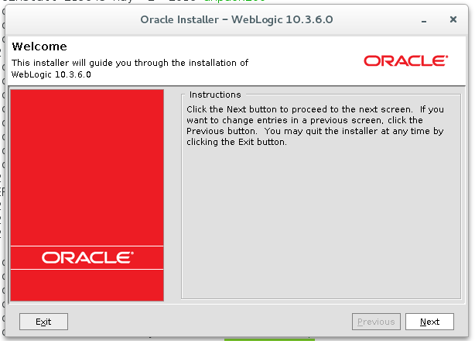

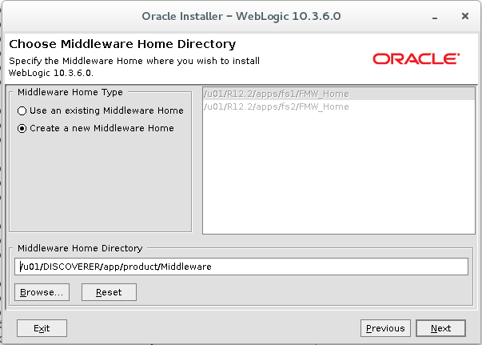

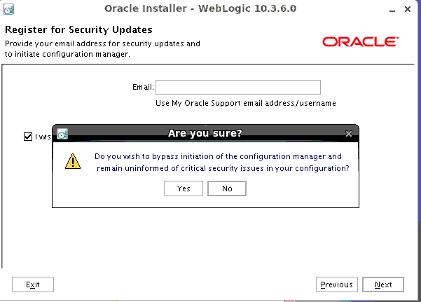

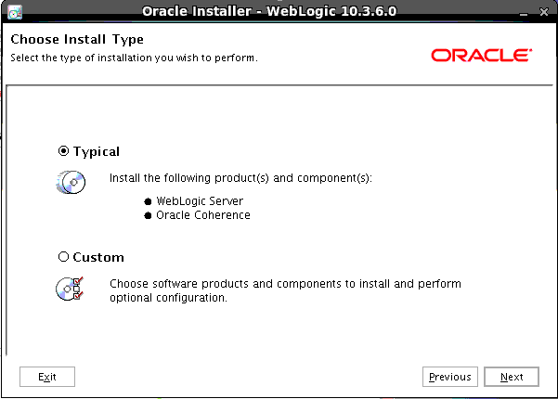

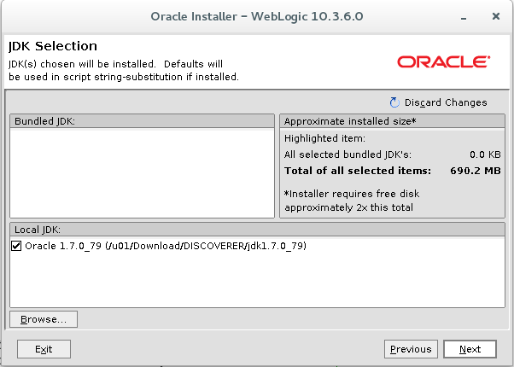

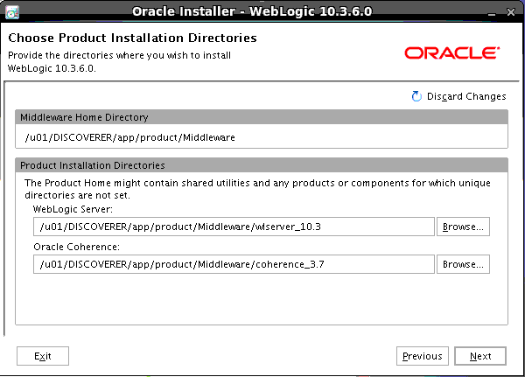

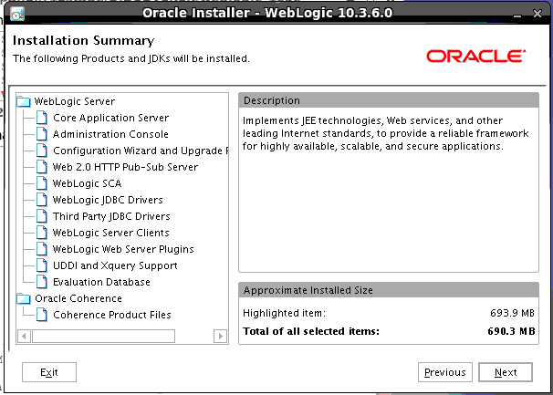

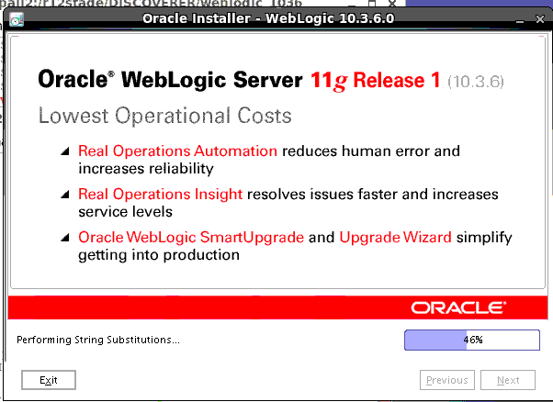

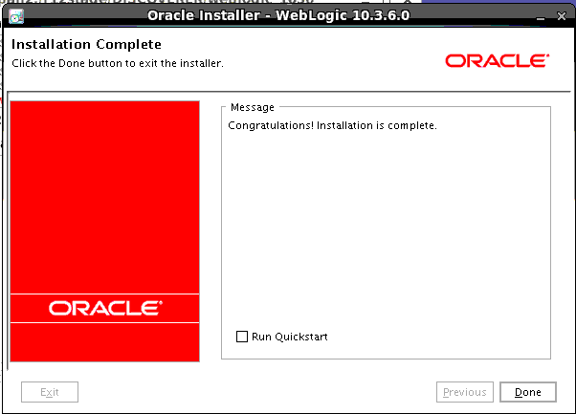

**Make sure to unselect Run Quickstart**

**5.2 Install Fusion Middleware Forms, reports, discoverer 11.1.1.2 “software only” Option.**

[apploaq1@shnpc1oappin2 disc11.1.1.2]$ cd /u01/Download/DISCOVERER/disc11.1.1.2

[apploaq1@shnpc1oappin2 disc11.1.1.2]$ cd Disk1

[apploaq1@shnpc1oappin2 Disk1]$ ./runInstaller

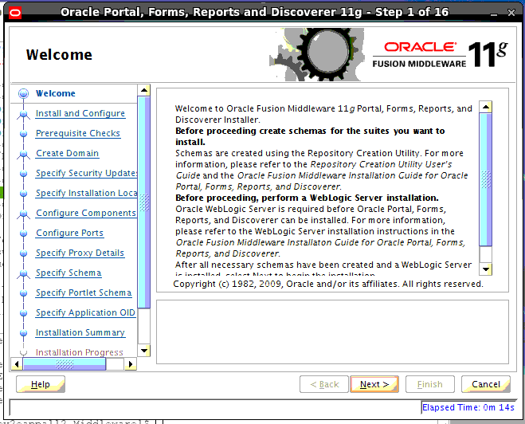

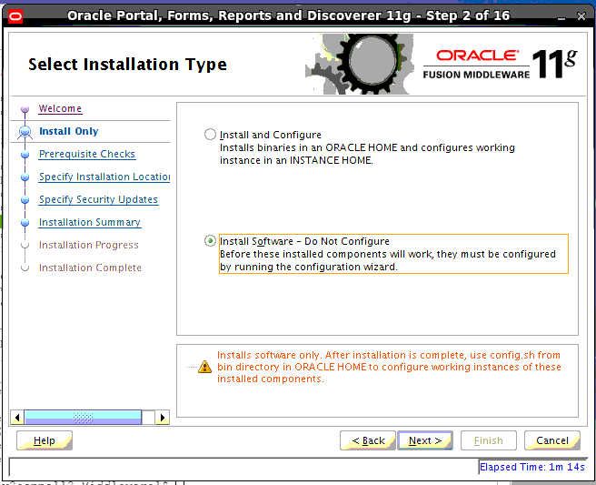

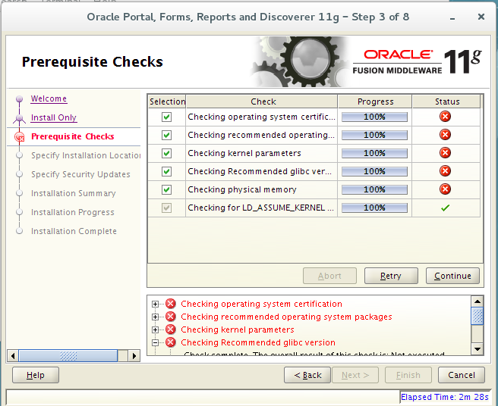

Ignore the above error messages and continue…

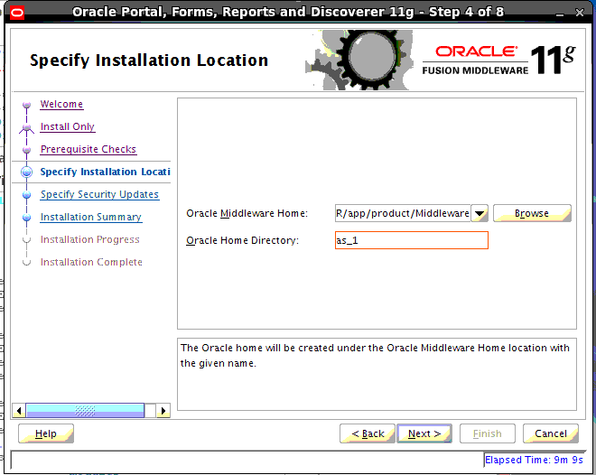

Home: /u01/DISCOVERER/app/product/Middleware

Home directory: as_1

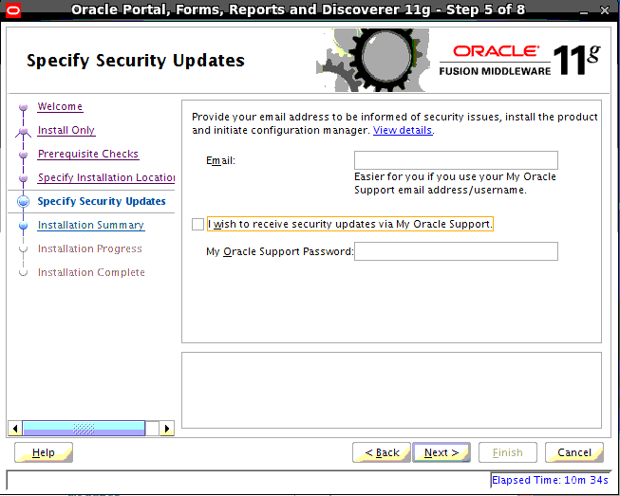

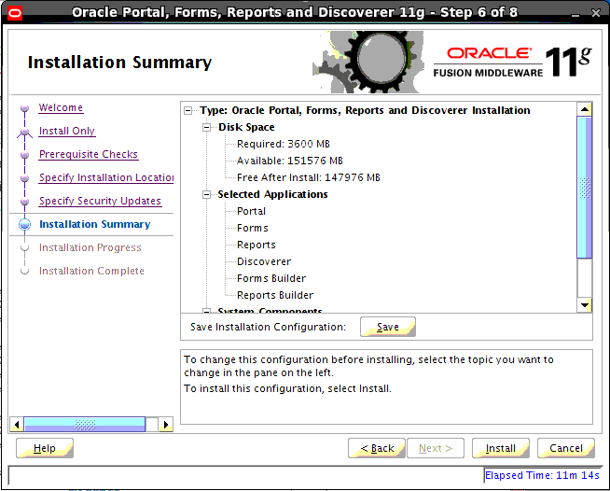

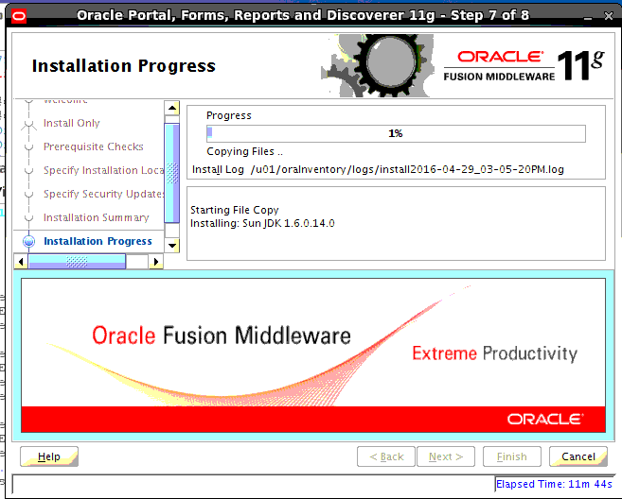

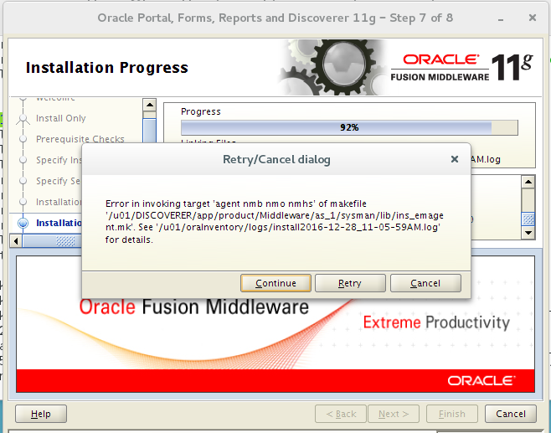

Can ignore this error. Click “Continue”.

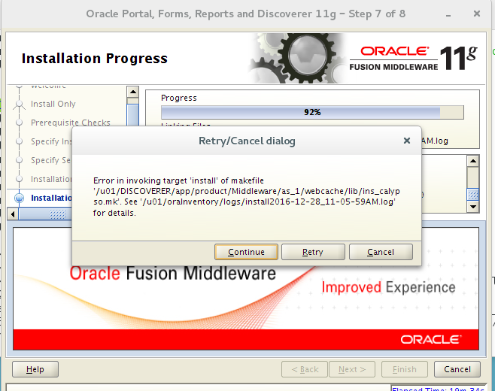

Can ignore this error. Click “Continue”.

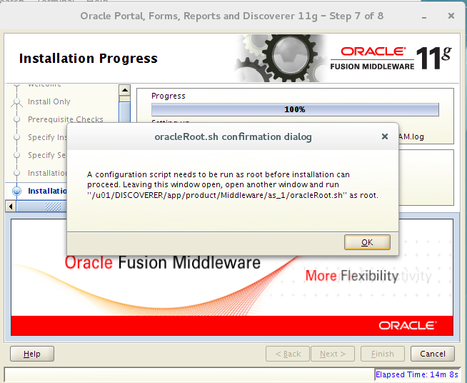

[root@shnpc1oappin2 as_1]# cd /u01/DISCOVERER/app/product/Middleware/as_1

[root@shnpc1oappin2 as_1]# sh oracleRoot.sh

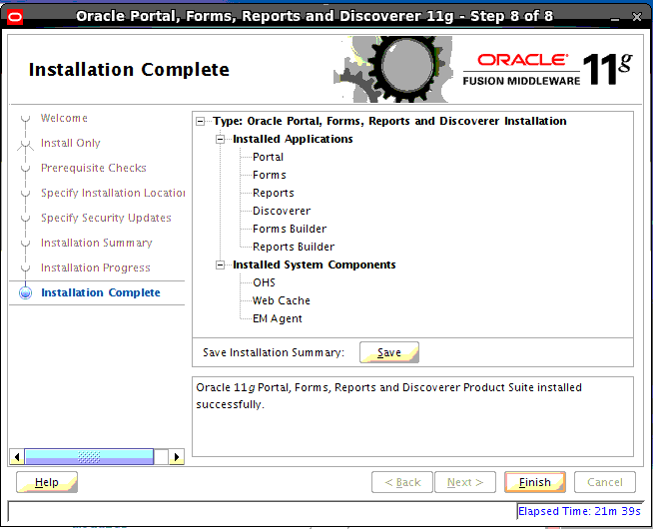

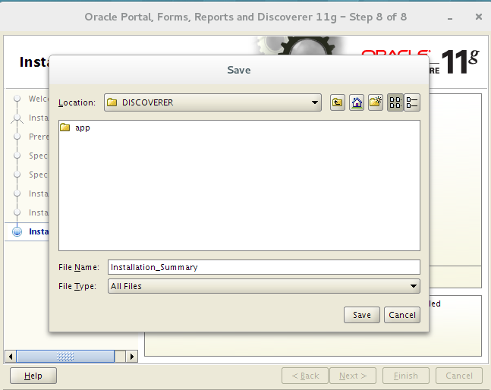

**5.3 FMW 11.1.1.7 Upgrade from FMW 11.1.1.2:**

[apploaq1@shnpc1oappin2 disc_11.1.1.7_patchset]$ cd /u01/Download/DISCOVERER/disc_11.1.1.7_patchset

Cd Disk1

./ runInstaller

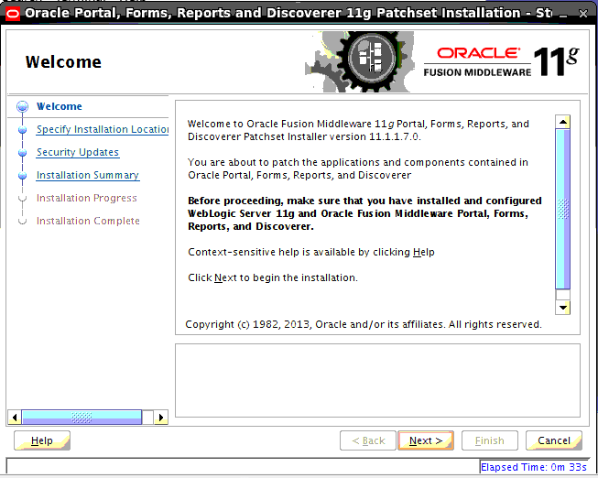

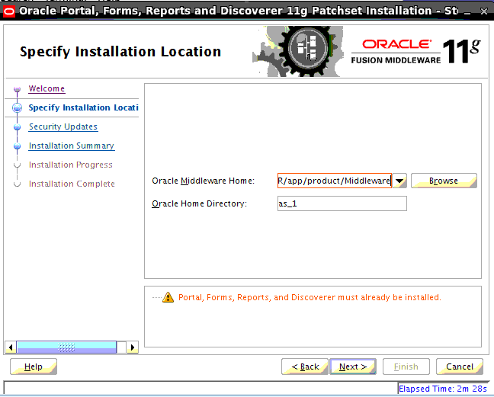

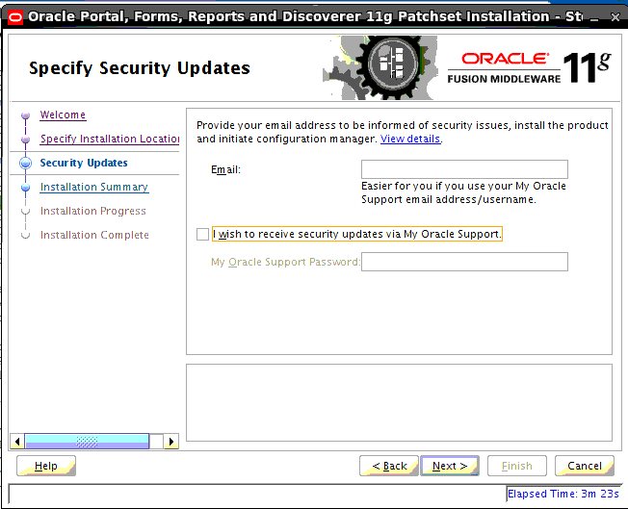

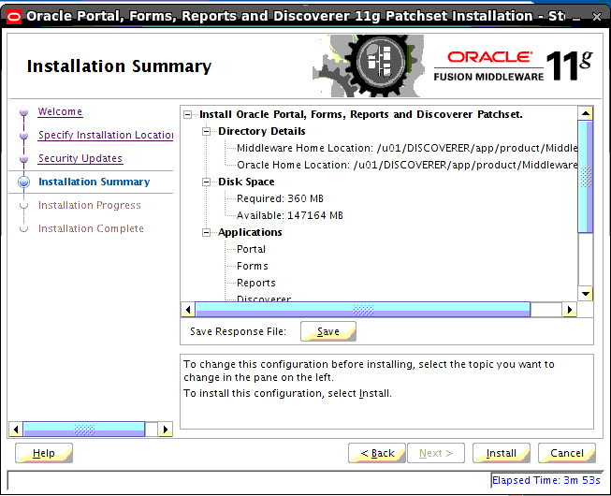

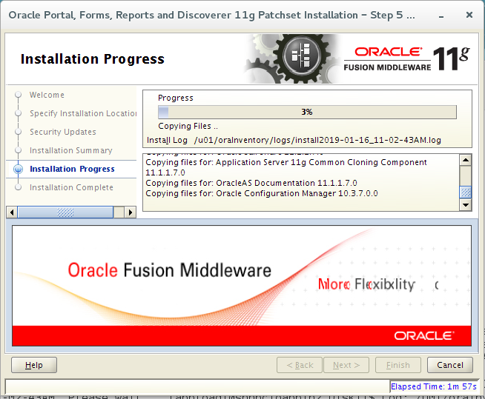

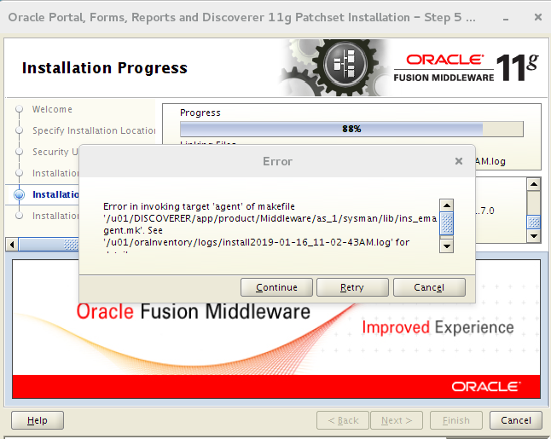

Ignore the error and continue.

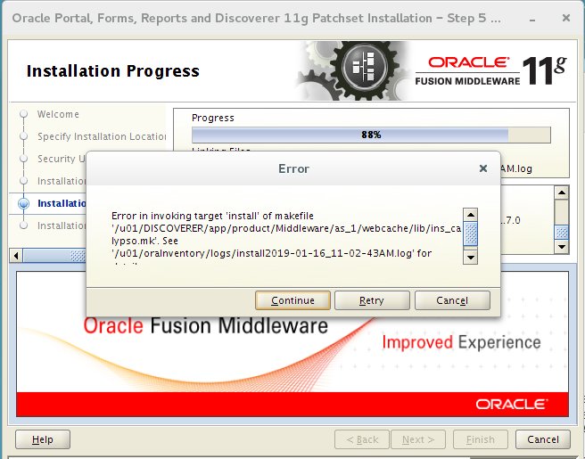

Ignore the error and continue.

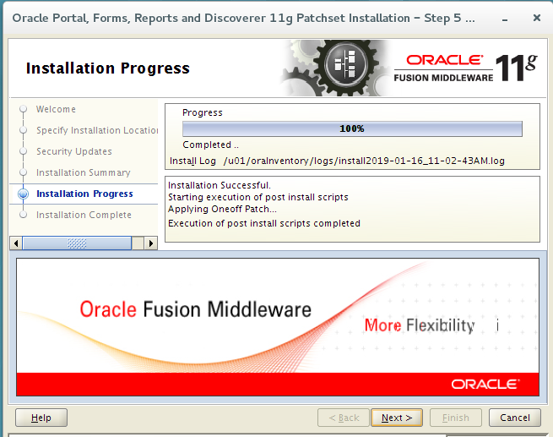

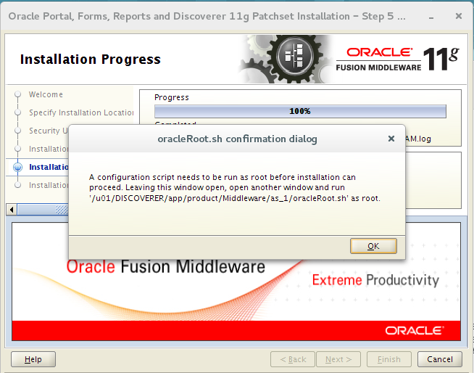

[root@shnpc1oappin2 as_1]# cd /u01/DISCOVERER/app/product/Middleware/as_1

[root@shnpc1oappin2 as_1]# sh oracleRoot.sh

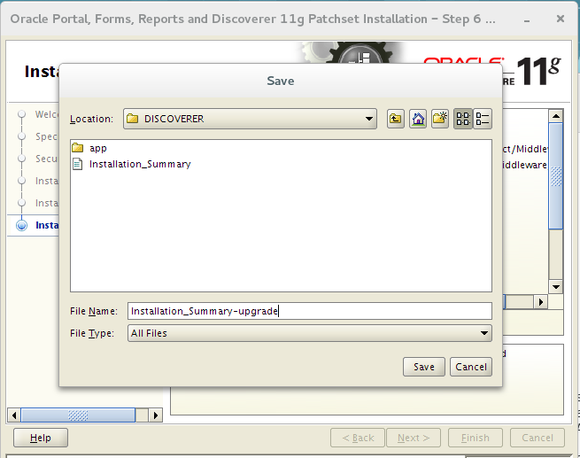

**5.4 Configure Domain**

[apploaq1@shnpc1oappin2 bin]$ cd /u01/DISCOVERER/app/product/Middleware/as_1/bin

[apploaq1@shnpc1oappin2 bin]$ ./config.sh

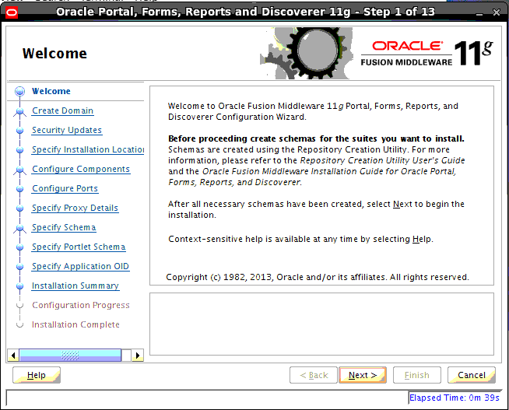

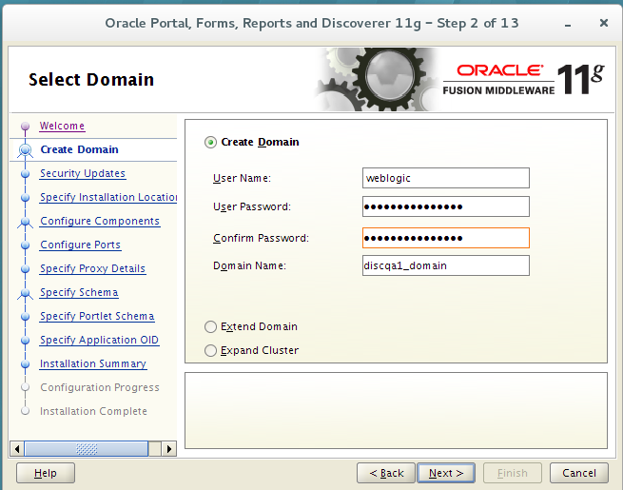

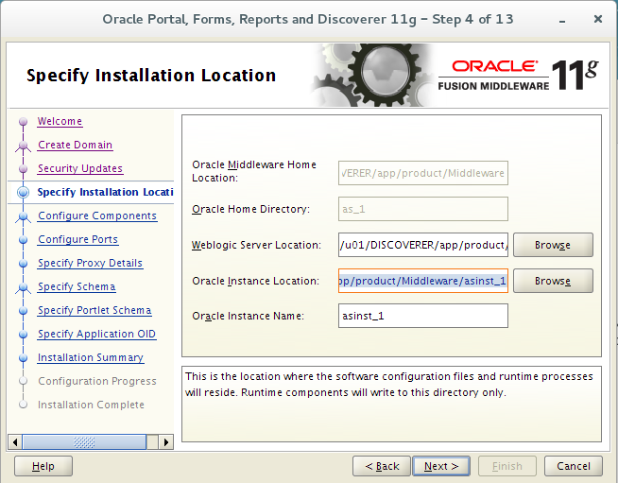

Weblogic server location: /u01/DISCOVERER/app/product/Middleware/wlserver_10.3

Oracle instance location: /u01/DISCOVERER/app/product/Middleware/asinst_1

Oracle instance name: asinst_1

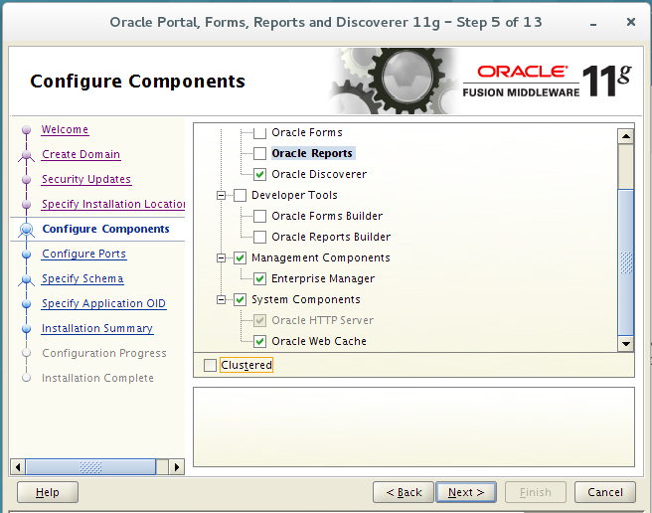

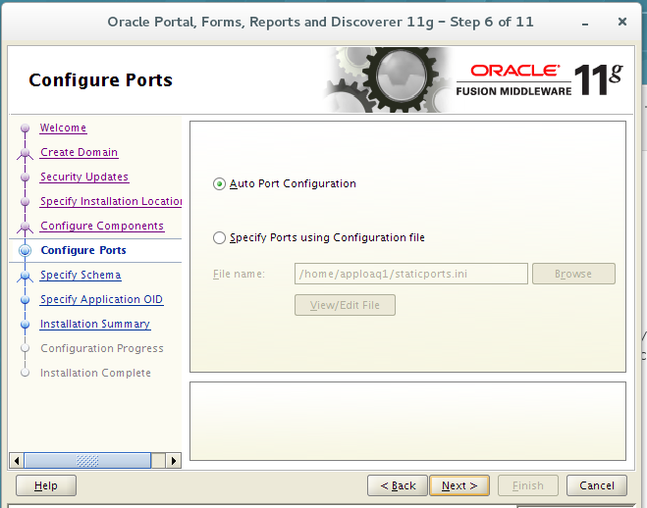

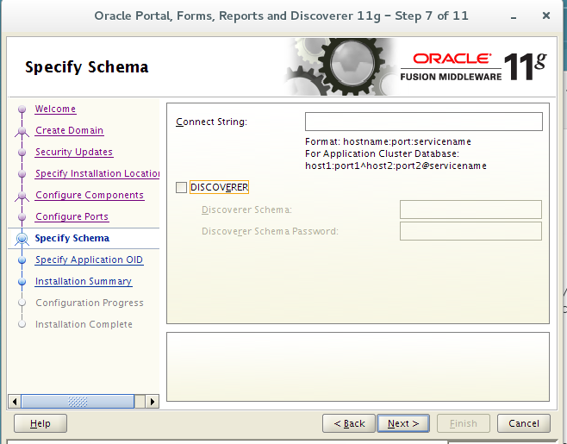

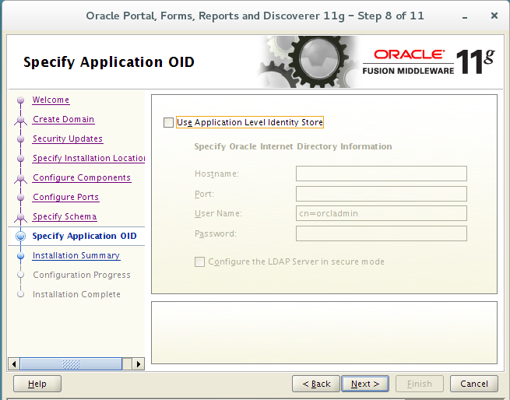

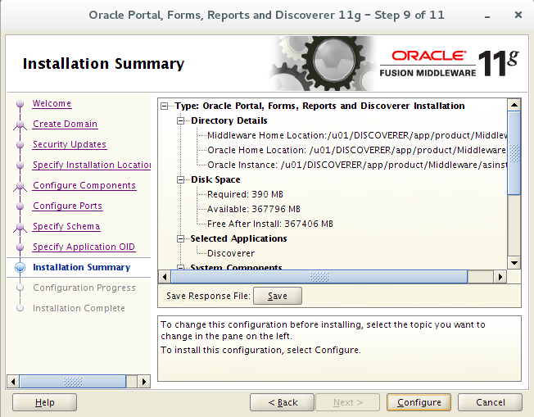

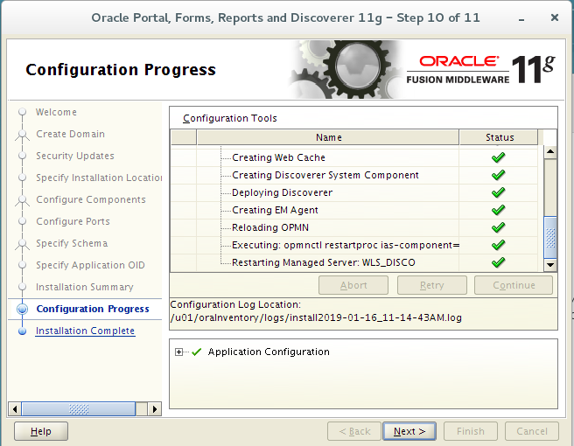

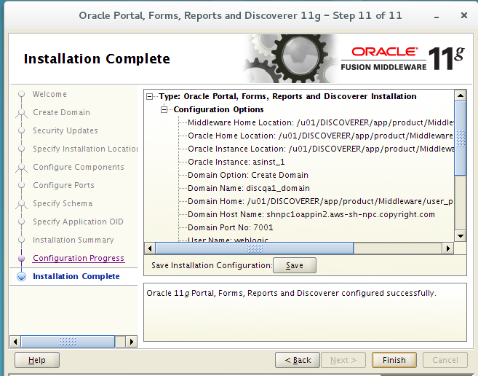

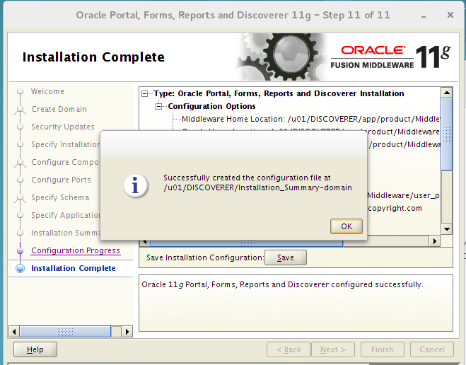

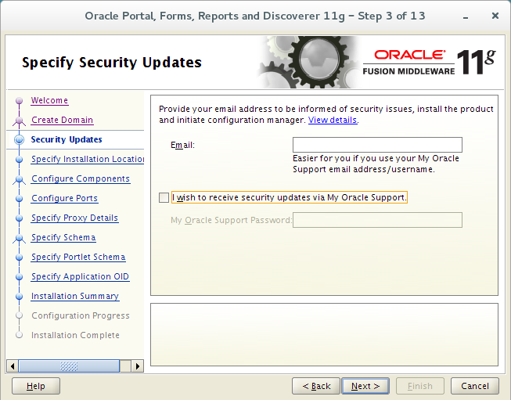

**5.5 Apply the latest CPU patch for Discoverer Home**

**5.5.1 Update and Test Shutdown and Startup Scripts:**

Create environment file:

Vi /u01/DISCOVERER/app/product/Middleware/disco.env

MW_HOME=/u01/DISCOVERER/app/product/Middleware;

export MW_HOME

DOMAIN_HOME=$MW_HOME/user_projects/domains/discpre1_domain;

export DOMAIN_HOME

WL_HOME=$MW_HOME/wlserver_10.3;

export WL_HOME

ORACLE_HOME=$MW_HOME/as_1;

export ORACLE_HOME

ORACLE_INSTANCE=$MW_HOME/asinst_1;

export ORACLE_INSTANCE

PATH=$WL_HOME/server/bin:$DOMAIN_HOME/bin:$ORACLE_INSTANCE/bin:$ORACLE_HOME/OPat

ch:$PATH;

export PATH

cd ~/bin

update scripts below to make sure all the directory paths are correct:

shutDISCOVER.sh

startDISCOVER.sh

**Shutdown Discovered server:**

./shutDISCOVER.sh

Run “ps -ef | grep DISC”, if some DISC processes are still running, kill them.

**Source environment file:**

[apploaq1@shnpc1oappin2 bin]$ . /u01/DISCOVERER/app/product/Middleware/disco.env

**Apply CPU patch:**

Cd /u01/Download/DISCOVERER/CPUPATCH/18423801

[apploaq1@shnpc1oappin2 18423801]$ $ORACLE_HOME/OPatch/opatch apply

Oracle Interim Patch Installer version 11.1.0.9.9

Copyright (c) 2012, Oracle Corporation. All rights reserved.

Oracle Home : /u01/DISCOVERER/app/product/Middleware/as_1

Central Inventory : /u01/oraInventory

from : /u01/DISCOVERER/app/product/Middleware/as_1/oraInst.loc

OPatch version : 11.1.0.9.9

OUI version : 11.1.0.9.0

Log file location : /u01/DISCOVERER/app/product/Middleware/as_1/cfgtoollogs/opatch/18423801_Jan_17_2019_10_00_46/apply2019-01-17_10-00-46AM_1.log

OPatch detects the Middleware Home as "/u01/DISCOVERER/app/product/Middleware"

Applying interim patch '18423801' to OH '/u01/DISCOVERER/app/product/Middleware/as_1'

Verifying environment and performing prerequisite checks...

All checks passed.

Please shutdown Oracle instances running out of this ORACLE_HOME on the local system.

(Oracle Home = '/u01/DISCOVERER/app/product/Middleware/as_1')

Is the local system ready for patching? [y|n]

y

User Responded with: Y

Backing up files...

Patching component oracle.opmn, 11.1.1.7.0...

Verifying the update...

Patch 18423801 successfully applied

Log file location: /u01/DISCOVERER/app/product/Middleware/as_1/cfgtoollogs/opatch/18423801_Jan_17_2019_10_00_46/apply2019-01-17_10-00-46AM_1.log

OPatch succeeded.

**Startup Discoverer:**

./startDISCOVER.sh

Verify all four webpages below are up and running:

Administrator Console: http://shnpc1oappin2.aws-sh-npc.copyright.com:7001/console

EM Console: http://shnpc1oappin2.aws-sh-npc.copyright.com:7001/em

Discoverer Viewer URL: http://shnpc1oappin2.aws-sh-npc.copyright.com:8090/discoverer/viewer

Discover Plus URL: <http://shnpc1oappin2.aws-sh-npc.copyright.com:8090/discoverer/plus>

**5.6 Configure e-Business with Discoverer:**

**5.6.1 Configure dbc files:**

**Source e-Business environment:**

[apploaq1@shnpc1oappin2 bin]$ source /u01/R12.2/apps/EBSapps.env run

[apploaq1@shnpc1oappin2 secure]$ cd /u01/R12.2/apps/fs1/inst/apps/OAQ1_shnpc1oappin2/appl/fnd/12.0.0/secure

[apploaq1@shnpc1oappin2 secure]$ cp -p OAQ1.dbc /u01/DISCOVERER/app/product/Middleware/asinst_1/config/Discoverer/Discoverer_asinst_1/

[apploaq1@shnpc1oappin2 secure]$ cd /u01/DISCOVERER/app/product/Middleware/asinst_1/config/Discoverer/Discoverer_asinst_1

[apploaq1@shnpc1oappin2 Discoverer_asinst_1]$ cp OAQ1.dbc oaq1.dbc

[apploaq1@shnpc1oappin2 Discoverer_asinst_1]$ ll

total 8

-rw-------. 1 apploaq1 oinstall 825 Jan 17 11:12 oaq1.dbc

-rw-------. 1 apploaq1 oinstall 825 Jan 15 11:16 OAQ1.dbc

**5.6.2 Configure tnsnames files:**

[apploaq1@shnpc1oappin2 admin]$ cd /u01/R12.2/apps/fs1/inst/apps/OAQ1_shnpc1oappin2/ora/10.1.2/network/admin

[apploaq1@shnpc1oappin2 admin]$ cp tnsnames.ora /u01/DISCOVERER/app/product/Middleware/asinst_1/config/

**5.6.3 Configure application:**

**Lunch e-Business apps:**

http://shnpc1oappin2.aws-sh-npc.copyright.com:8006

Login as “sysadmin”, go to “System Administrator” -> “Profile” -> “System”, search %DISC%, update the following parameters:

ICX: Discoverer Launcher → / http://shnpc1oappin2.aws-sh-npc.copyright.com:8090/discoverer/plus?Connect=[APPS_SECURE]

ICX: Discoverer Viewer Launcher --> [http://shnpc1oappin2.aws-sh-npc.copyright.com:8090/discoverer/viewer?Connect=[APPS_SECURE](http://shnpc1oappin2.aws-sh-npc.copyright.com:8090/discoverer/viewer?Connect=%5bAPPS_SECURE)]

ICX: Discoverer Release -->11

ICX: Discoverer use Viewer → yes

ICX: Discoverer Default End User Layer Schema Prefix -->EUL4

ICX: Discoverer End User Layer Language Override -->American English

ICX: Discoverer Parameters --> exitURL=http://shnpc1oappin2.aws-sh-npc.copyright.com:8006/OA_HTML/OA.jsp?

OAFunc=OAHOMEPAGE

Discoverer DBC filename override ---><NULL>

Update application context file:

[apploaq1@shnpc1oappin2 admin]$ cd /u01/R12.2/apps/fs1/inst/apps/OAQ1_shnpc1oappin2/appl/admin

vi OAQ1_shnpc1oappin2.xml

Update an entry below:

<disco_url oa_var="s_disco_url" customized="yes">[http://shnpc1oappin2.aws-sh-npc.copyright.com:8090</disco_url](http://shnpc1oappin2.aws-sh-npc.copyright.com:8090%3c/disco_url)>

**Stop e-Business apps:**

**Cd ~/bin**

**./shutOAQ1apps.sh**

**Run autoconfig:**

[apploaq1@shnpc1oappin2 ~]$ cd $ADMIN_SCRIPTS_HOME

[apploaq1@shnpc1oappin2 scripts]$ ./adautocfg.sh

Enter the APPS user password:

The log file for this session is located at: /u01/R12.2/apps/fs1/inst/apps/OAQ1_shnpc1oappin2/admin/log/01171152/adconfig.log

AutoConfig is configuring the Applications environment...

AutoConfig will consider the custom templates if present.

Using CONFIG_HOME location : /u01/R12.2/apps/fs1/inst/apps/OAQ1_shnpc1oappin2

Classpath : /u01/R12.2/apps/fs1/FMW_Home/Oracle_EBS-app1/shared-libs/ebs-appsborg/WEB-INF/lib/ebsAppsborgManifest.jar:/u01/R12.2/apps/fs1/EBSapps/comn/java/classes

Using Context file : /u01/R12.2/apps/fs1/inst/apps/OAQ1_shnpc1oappin2/appl/admin/OAQ1_shnpc1oappin2.xml

Context Value Management will now update the Context file

Updating Context file...COMPLETED

Attempting upload of Context file and templates to database...COMPLETED

Configuring templates from all of the product tops...

Configuring AD_TOP........COMPLETED

Configuring FND_TOP.......COMPLETED

Configuring ICX_TOP.......COMPLETED

Configuring MSC_TOP.......COMPLETED

Configuring IEO_TOP.......COMPLETED

Configuring BIS_TOP.......COMPLETED

Configuring CZ_TOP........COMPLETED

Configuring SHT_TOP.......COMPLETED

Configuring AMS_TOP.......COMPLETED

Configuring CCT_TOP.......COMPLETED

Configuring WSH_TOP.......COMPLETED

Configuring CLN_TOP.......COMPLETED

Configuring OKE_TOP.......COMPLETED

Configuring OKL_TOP.......COMPLETED

Configuring OKS_TOP.......COMPLETED

Configuring CSF_TOP.......COMPLETED

Configuring IBY_TOP.......COMPLETED

Configuring JTF_TOP.......COMPLETED

Configuring MWA_TOP.......COMPLETED

Configuring CN_TOP........COMPLETED

Configuring CSI_TOP.......COMPLETED

Configuring WIP_TOP.......COMPLETED

Configuring CSE_TOP.......COMPLETED

Configuring EAM_TOP.......COMPLETED

Configuring GMF_TOP.......COMPLETED

Configuring PON_TOP.......COMPLETED

Configuring FTE_TOP.......COMPLETED

Configuring ONT_TOP.......COMPLETED

Configuring AR_TOP........COMPLETED

Configuring AHL_TOP.......COMPLETED

Configuring IES_TOP.......COMPLETED

Configuring OZF_TOP.......COMPLETED

Configuring CSD_TOP.......COMPLETED

Configuring IGC_TOP.......COMPLETED

AutoConfig completed successfully.

Cd “/bin

./startOAQ1apps.sh

**Recopy the dbc file to the discoverer server:**

[apploaq1@shnpc1oappin2 secure]$ cd /u01/R12.2/apps/fs1/inst/apps/OAQ1_shnpc1oappin2/appl/fnd/12.0.0/secure

[apploaq1@shnpc1oappin2 secure]$ cp -p OAQ1.dbc /u01/DISCOVERER/app/product/Middleware/asinst_1/config/Discoverer/Discoverer_asinst_1/

[apploaq1@shnpc1oappin2 secure]$ cd /u01/DISCOVERER/app/product/Middleware/asinst_1/config/Discoverer/Discoverer_asinst_1

[apploaq1@shnpc1oappin2 Discoverer_asinst_1]$ cp OAQ1.dbc oaq1.dbc

**Stop and Start Opmn processes:**

[apploaq1@shnpc1oappin2 bin]$ . /u01/DISCOVERER/app/product/Middleware/disco.env

[apploaq1@shnpc1oappin2 bin]$ $ORACLE_INSTANCE/bin/opmnctl stopall

[apploaq1@shnpc1oappin2 bin]$ $ORACLE_INSTANCE/bin/opmnctl status

opmnctl status: opmn is not running.

[apploaq1@shnpc1oappin2 bin]$ $ORACLE_INSTANCE/bin/opmnctl startall

opmnctl startall: starting opmn and all managed processes...

[apploaq1@shnpc1oappin2 bin]$ $ORACLE_INSTANCE/bin/opmnctl status

Processes in Instance: asinst_1

---------------------------------+--------------------+---------+---------

ias-component | process-type | pid | status

---------------------------------+--------------------+---------+---------

emagent_asinst_1 | EMAGENT | 22793 | Alive

Discoverer_asinst_1 | PreferenceServer | 22794 | Alive

Discoverer_asinst_1 | ServicesStatus | 22791 | Alive

webcache1 | WebCache-admin | 22790 | Alive

webcache1 | WebCache | 22789 | Alive

ohs1 | OHS | 22788 | Alive

**Login to e-Business and do a quick sanity check.**

**5.6.x. Optional:**

**Recompile APPS objects**

**[apploaq1@shnpc1oappin2 bin]$ source /u01/R12.2/apps/EBSapps.env run**

[apploaq1@shnpc1oappin2 bin]$ adadmin

Copyright (c) 2002, 2012 Oracle Corporation

Redwood Shores, California, USA

Oracle E-Business Suite AD Administration

Version 12.2.0

NOTE: You may not use this utility for custom development

unless you have written permission from Oracle Corporation.

Your default directory is '/u01/R12.2/apps/fs1/EBSapps/appl'.

Is this the correct APPL_TOP [Yes] ?

AD Administration records your AD Administration session in a text file

you specify. Enter your AD Administration log file name or press [Return]

to accept the default file name shown in brackets.

Filename [adadmin.log] :

************* Start of AD Administration session *************

AD Administration version: 12.2.0

AD Administration started at: Thu Jan 17 2019 12:06:32

APPL_TOP is set to /u01/R12.2/apps/fs1/EBSapps/appl

You can be notified by email if a failure occurs.

Do you wish to activate this feature [No] ?

Please enter the batchsize [1000] :

Please enter the name of the Oracle E-Business Suite System that this

APPL_TOP belongs to.

The Applications System name must be unique across all Oracle

Applications Systems at your site, must be from 1 to 30 characters

long, may only contain alphanumeric and underscore characters,

and must start with a letter.

Sample Applications System names are: "prod", "test", "demo" and

"Development_2".

Applications System Name [OAQ1] : OAQ1 *

NOTE: If you do not currently have certain types of files installed

in this APPL_TOP, you may not be able to perform certain tasks.

Example 1: If you don't have files used for installing or upgrading

the database installed in this area, you cannot install or upgrade

the database from this APPL_TOP.

Example 2: If you don't have forms files installed in this area, you cannot

generate them or run them from this APPL_TOP.

Example 3: If you don't have concurrent program files installed in this area,

you cannot relink concurrent programs or generate reports from this APPL_TOP.

Do you currently have files used for installing or upgrading the database

installed in this APPL_TOP [YES] ? YES *

Do you currently have Java and HTML files for HTML-based functionality

installed in this APPL_TOP [YES] ? YES *

Do you currently have Oracle E-Business Suite forms files installed

in this APPL_TOP [YES] ? YES *

Do you currently have concurrent program files installed

in this APPL_TOP [YES] ? YES *

Please enter the name Oracle E-Business Suite will use to identify this APPL_TOP.

The APPL_TOP name you select must be unique within an Oracle E-Business Suite

System, must be from 1 to 30 characters long, may only contain

alphanumeric and underscore characters, and must start with a letter.

Sample APPL_TOP Names are: "prod_all", "demo3_forms2", and "forms1".

APPL_TOP Name [shnpc1oappin2] : shnpc1oappin2 *

You are about to use or modify Oracle E-Business Suite product tables

in your ORACLE database 'OAQ1'

using ORACLE executables in '/u01/R12.2/apps/fs1/EBSapps/10.1.2'.

Is this the correct database [Yes] ?

AD Administration needs the password for your 'SYSTEM' ORACLE schema

in order to determine your installation configuration.

Enter the password for your 'SYSTEM' ORACLE schema:

The ORACLE username specified below for Application Object Library

uniquely identifies your existing product group: APPLSYS

Enter the ORACLE password of Application Object Library [APPS] :

AD Administration is verifying your username/password.

The status of various features in this run of AD Administration is:

<-Feature version in->

Feature Active? APPLTOP Data model Flags

------------------------------ ------- -------- ----------- -----------

CHECKFILE Yes 1 1 Y N N Y N Y

PREREQ Yes 6 6 Y N N Y N Y

CONCURRENT_SESSIONS No 2 2 Y Y N Y Y N

PATCH_TIMING Yes 2 2 Y N N Y N Y

PATCH_HIST_IN_DB Yes 6 6 Y N N Y N Y

SCHEMA_SWAP Yes 1 1 Y N N Y Y Y

JAVA_WORKER Yes 1 1 Y N N Y N Y

CODELEVEL Yes 1 1 Y N N Y N Y

Identifier for the current session is 20146

Reading product information from file...

Reading language and territory information from file...

Reading language information from applUS.txt ...

Reading database to see what industry is currently installed.

Reading FND_LANGUAGES to see what is currently installed.

Currently, the following language is installed:

Code Language Status

---- --------------------------------------- ---------

US American English Base

Your base language will be AMERICAN.

Setting up module information.

Reading database for information about the modules.

Saving module information.

Reading database for information about the products.

Reading database for information about how products depend on each other.

Reading topfile.txt ...

Saving product information.

AD code level : [C.7]

*** Maintaining the Run File System (in Hotpatch mode) ***

*** Edition Enabled User ***

AD Administration Main Menu

--------------------------------------------------

1. Generate Applications Files menu

2. Maintain Applications Files menu

3. Compile/Reload Applications Database Entities menu

4. Maintain Applications Database Entities menu

5. Exit AD Administration

Enter your choice [5] :

Then choose 3 and then 1

Complete! Thanks for Reading!